For
Sale
By
Owner

GET IT SOLD FAST!

TRBOTupelo.com
Tupelo Real-estate By Owner
SINGLE FAMILY HOME
$202,000
Year Built: 2001 3 Total Bedroom(s) 2.5 Total Bath(s) Approx. 2350 sq. ft.
Schools: Mooreville Schools
*Central Heat and Air with gas heat * 2 Car Garage * 1 acre(s)
*Living Room * Dining Room *Breakfast Area * Office *Walk-in-closets * Decorative Tile
*Fireplace *Security System *Fenced Backyard * Swimming Pool * Covered Patio

Please call: Timothy Senter (OWNER) 662-871-5681
view home at www.trbotupelo.com/111-RD-1552-Mooreville.html
111 Road 1552 Mooreville, MS 38857
$202,000
Beautiful and Private

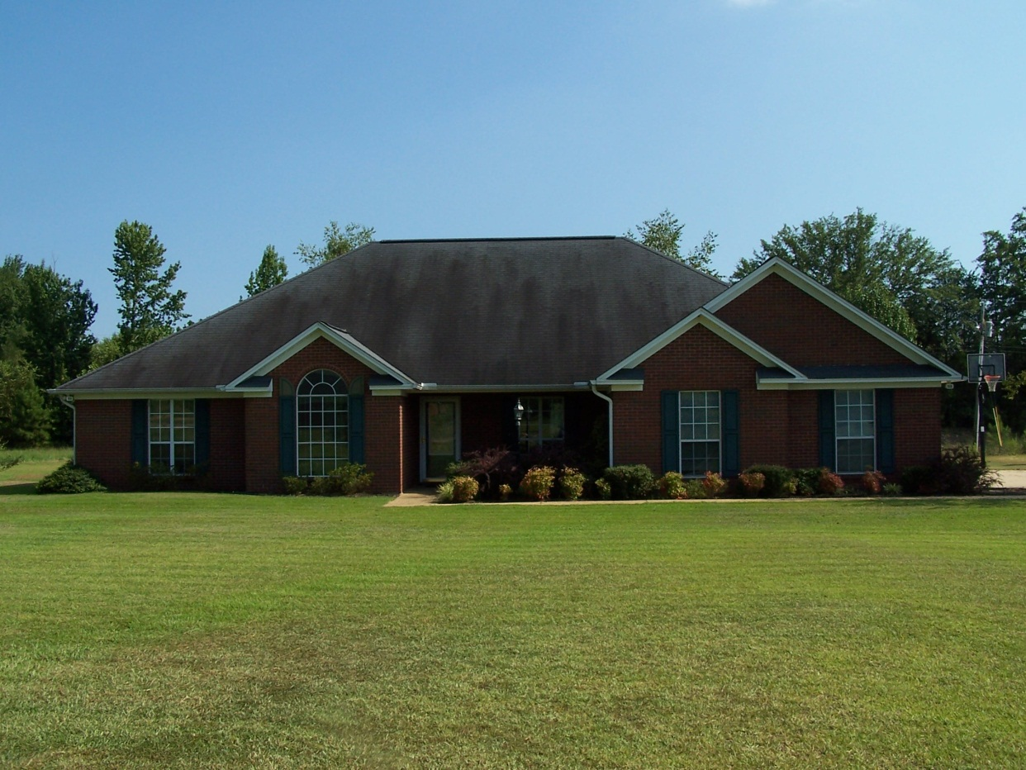
If you are looking for a quiet subdivision with a country setting then you have found your home. This homes features a spacious Master suite with a large walk in closet. The master bath has beautiful architectural features along with a garden tub and separate shower. You will also love the spacious family room that features a gas fireplace and is only a few steps away from your very own in-ground swimming pool. There is also an extra room that can be used as an office or study, formal dining room, Jack and Jill bedrooms, and a beautiful breakfast nook surrounded by large windows with a view of the pool. Also you will love the decorative tile located throughout the home. This home has been very well maintained both inside and out. The home has a large open front yard and a fenced in backyard that includes an 18x36 in-ground pool. This home is sure to please those that are looking for a beautiful home with lots of extras, for you and your family to enjoy.

